This takes place when the form is loaded:

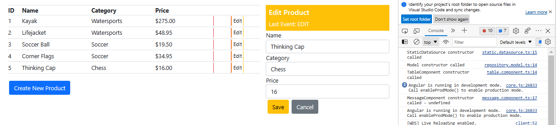

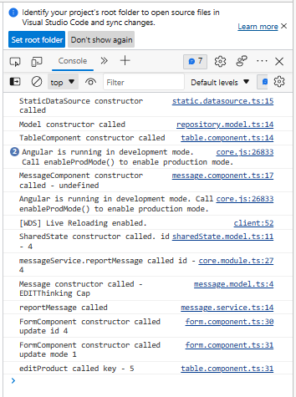

After ,

One of the Edit buttons was pressed.

